1. List of created users under a super user:

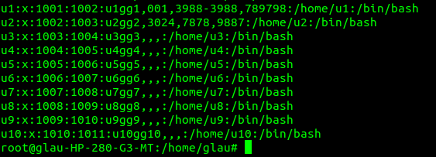**Command:** *adduser username*

1. Unassigned parameters to particular users:

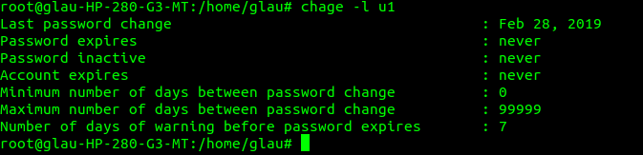**Command:** *chage -l username*

1. Modified parameters:

**Command:** *sudo chage -E 19/04/19 -m 5 -M 50 -I 50 -W 14 username*

1. 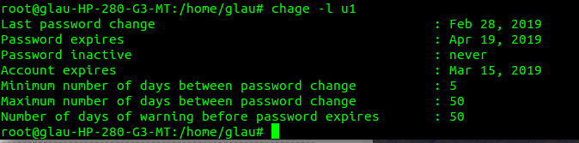Users added to groups:

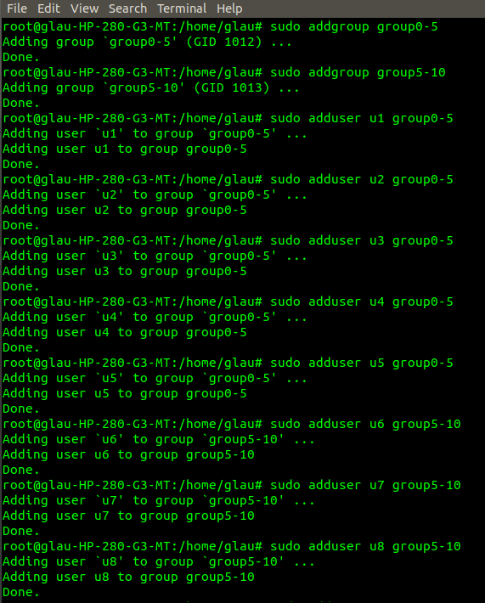**Command**: *sudo addgroup* groupname

1. Changing Permissions and delete users:

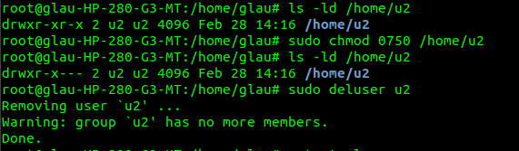**Command:** *ls -ld /home/username and deluser groupname*

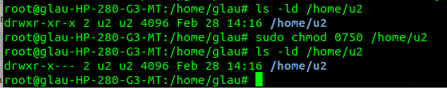**Result of permission change:**